**FLOURENCE INVERTER CEILING FANS:**

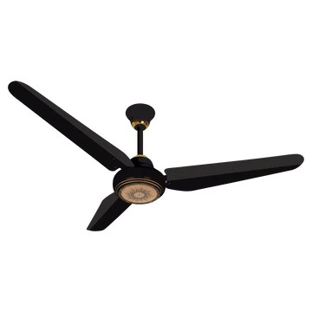

**Price: 9,450.00**

Florence Inverter Fans are a cutting-edge solution for efficient and effective cooling. Equipped with advanced inverter technology, these fans optimize airflow while minimizing power consumption, resulting in significant energy savings. Their sleek and modern designs not only enhance the aesthetic of any room but also provide a comfortable and eco-friendly experience. With features such as variable speed control, whisper-quiet operation, and automatic shut-off, Florence Inverter Fans offer unparalleled convenience, performance, and sustainability. Whether for residential or commercial use, these fans are an excellent choice for those seeking a reliable, efficient, and environmentally friendly cooling solution.

**Key features of flourence inverter ceiling fans include:**

* **Inverter Motor:** Provides energy efficiency and quieter operation compared to traditional motors.
* **Remote Control:** Allows easy adjustment of fan speed and settings from a distance.
* **Multi-Speed Settings:** Offers various speed options for customized airflow.
* **Durable Build:** Made with high-quality materials for long-lasting performance.
* **Reverse Function:** Allows the fan to reverse direction for improved air circulation in both summer and winter.
* **Sleek Design:** Modern and stylish designs to complement any room décor.
* **Energy Efficient:** Consumes less electricity, making it eco-friendly and cost-effective.